LESSON 6
Verbs
To bring | Trazer
To call | Ligar, telefonar
To clean | Limpar
To finish | Terminar
To get | Obter, conseguir
To give | Dar
To help | Ajudar
To invite | Convidar
To leave | Deixar, partir
To live | Morar, viver
To remember | Lembrar
To run | Correr
To say | Dizer
To see | Ver
To start | Começar
To stay | Ficar, permanecer
To teach (how to) | Ensinar
To think | Pensar
To travel | Viajar
To use | Usar
To visit | Visitar
To wait (for) | Esperar
To walk | Caminhar, andar
To wash | Lavar

Grammar Point
THERE + TO BE (present/past)
There is a car here.
There aren’t flowers in my garden.
Was there a bike near my car?
There weren’t balls in the sky yesterday at the park?

THERE + TO BE (present/past) + GOING TO BE:
There is going to be another soccer game next month.
There aren’t going to be a lot of people at the factory because of the virus.
Wasn’t there going to be an election last year?
There weren’t going to be songs to be listened.

IN, ON, AT

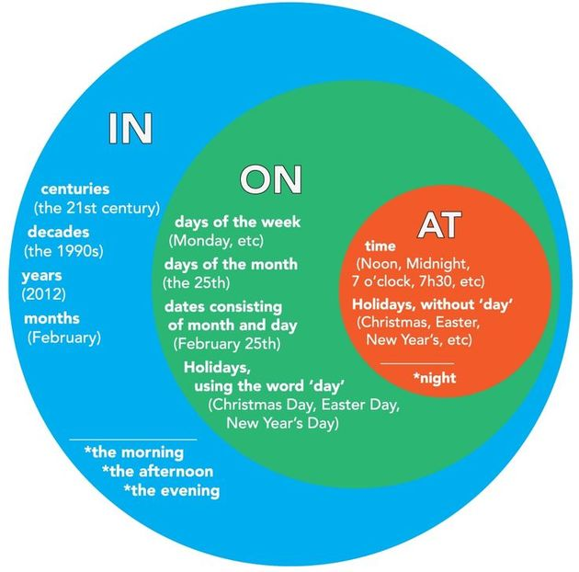

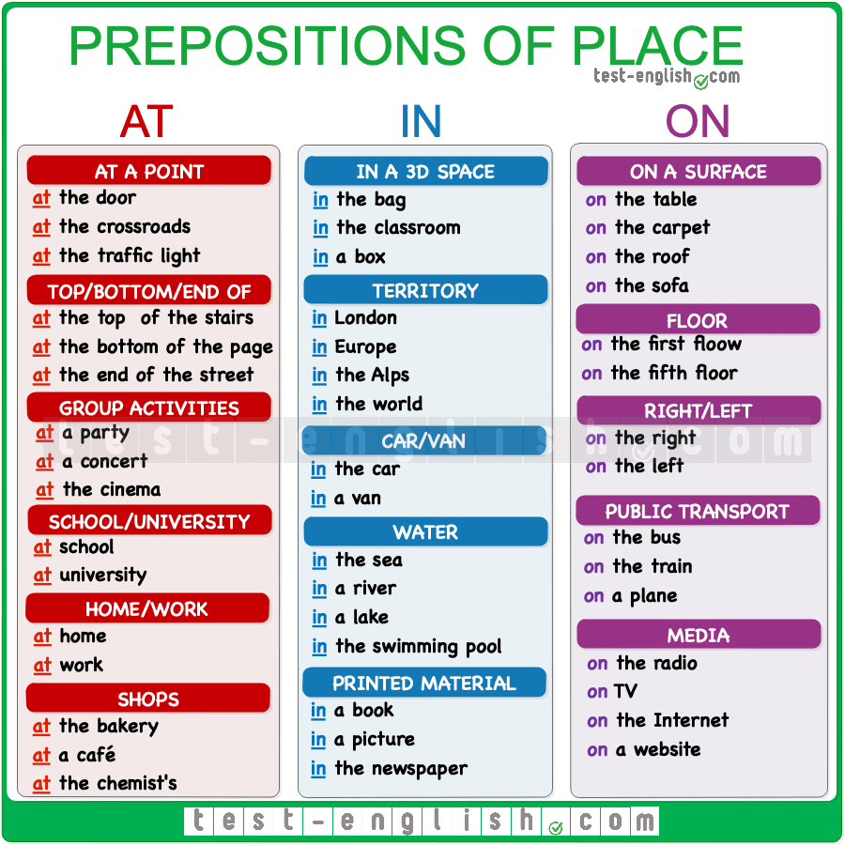

EXERCISES
- Complete with IN, ON or AT:
- The car keys are __in________ my room.
- I saw you when I was __in______ Rio de Janeiro.
- Could we meet _at_______ that restaurant near your house?
- Melanie lives __at_____ 566 Brooklyn Street.
- Please meet me _at_______ 6 p.m.
- I don’t play volleyball ___on______ Mondays.
- He went to Paris ___on_________ 8th November.
- I’ll be __at______ work all the weekend.
- Sarah will go to the United States ___in______ the summer.
- Her car was _at_______ the street.
- They never saw in _______ their arm.
- Anna is playing __at______ that empty box.
- The train will leave__at________ five minutes.
- ____on______ 1968, my father was working __at______ that marketplace.

- Translate into English:

- Ele deveria trabalhar no restaurante porque ele é muito bom.
He must works in the restaurant because he is much better.
- Tem muito pó na cozinha. A empregada tem que limpá-la hoje.
There are much poder in the kitchen. The maid have to clean today.
- Meu dicionário bilíngue não está na mochila e meu lápis está na mesa.
my double language dictionary isn´t be in the bag and my pencil is on the table.
- No dia 5 de setembro, eu vou para o Brasil e morarei em São Paulo.
On september 5th, i ‘m going to Brazil and i’m going to live in São Paulo.
- Em 2020, nós não tivemos aulas mas em fevereiro, tudo será diferente.
In 2020, we dind’t have classes but on february, all is going different.
- Quando eu posso começar a reunião? Às 18h.
When can I begin the meeting? At 6PM.
- Os Beatles eram populares em 1960.
The Beatles were going to popular in 1960.
- Vai haver uma eleição este ano? Ela será para prefeito, governador ou presidente?
Is there going to an election this year? Is this going to mayor, government or presidente?
- Ia haver um espelho no meu quarto novo mas meu marido não quis. Agora nós só temos cama e travesseiros.
There was going to have a mirror in my new bedroom but my husband dind’t want.
- Havia muitos casais nesta igreja. Todos eles querem se casar este ano.
There weren’t have many couples at this church. All of them want to marry this year.
- Houve uma festa na casa do contador e eu não fui porque ele não gosta de mim e não me convidou.
There was a party at counte house and i dind’t went because he doesnt likes me and dindt invited me.
- Vai haver uma festa no nosso escritório na próxima semana e eu vou convidar minha vizinha para ir comigo.
There is going to a party in our office on the next week and i’m going to invite my neighbor to go with me.
- Não vai haver uma reunião amanhã porque o supervisor não pode vir aqui. Ele está doente.
There isnt going to a meet tomorrow because the boss doenst come here. He is sick.
- Ia ter aulas na escola mas ela está fechada por causa do coronavírus.
There were going to classes at school but it’s close because of coronavirus.
- Não vai haver relatórios para escrever este mês. Isso é muito bom.
There arent going to reports to write this month. This is so good.
- Vai haver comida suficiente para todas essas pessoas? Eles estão com fome. (famintos)
Is There going to enough food to all this people? They are hungry.
- Choose the one word or phrase that best keeps the meaning of the original sentence:

- Located in New York City, Greenwich Village gained a reputation for bohemianism due to its populace of artists and freethinkers.
  - Desired
  - Promoted
  - Deserved
  - Acquired

- In certain types of quartz, bands of color form and irregular pattern.
- Shades
- Grains
- Drops
- Stripes

- After Reading Philip Morrison’s paper on gamma-ray astronomy in 1959, a fellow physicist was prompted to ask, “Wouldn’t using gamma rays be a good way to communicate across the galaxy?”
- Petitioned
- Cautioned
- Motivated
- Tempted

- The typical shoe of the Middle Ages was a soft, clinging moccasin that extended to the ankle.
- Close-fitting
- Comfortable
- Cleverly made
- Leather

- Laurels are valued for their aromatic oils and spices, edible fruits, and timber.
- Blossoms
- Leaves
- Wood
- Sap

- The plays of Eugene O’Neill, characterized by their unsettling questions and tumultuous struggles with fate, transformed the American theater.
- Thrilling
- Troubling
- Refreshing
- Frightening

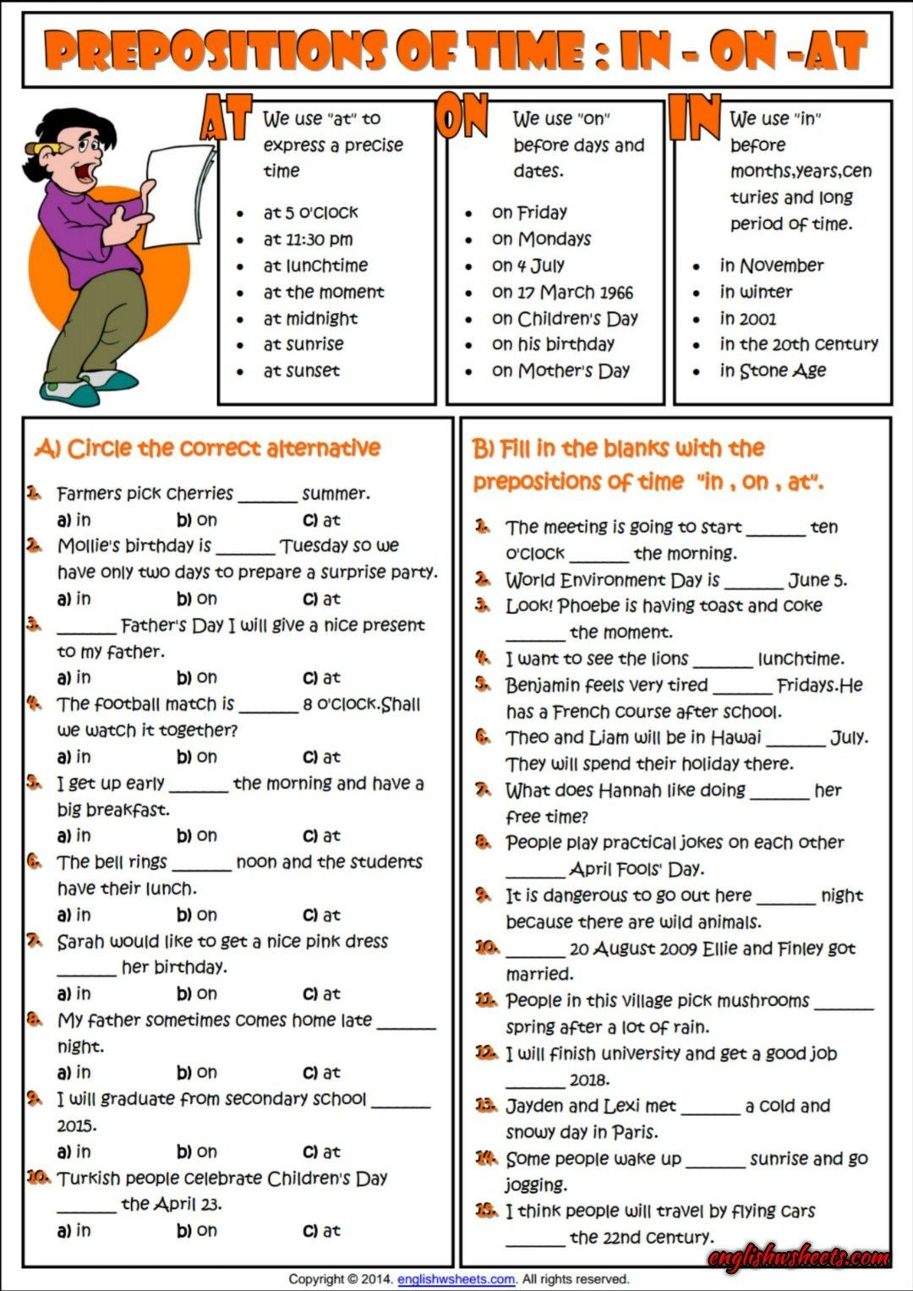
A) 1a; 2b; 3b; 4c; 5c; 6c; 7c; 8c; 9a; 10b
B) 1at;on; 2on; 3at; 4at; 5on; 6in; 7at; 8on; 9at; 10on; 11in; 12in; 13on; 14on; 15in

